Bouncy Egg: Cool Science Experiment for Kids
What happens when you submerge a raw egg in vinegar for days? Check out how you can make a bouncy egg with your kids in this science experiment.
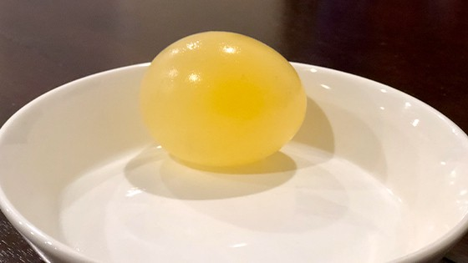

In this experiment, we are going to take an egg and make the eggshell disappear. Moreover, the naked egg is now going to be rubbery and bouncy!

How to Make a Bouncy Egg

Supplies:
- Raw egg
- Glass jar
- White vinegar

Directions:
- Place the raw egg carefully in the jar. If it cracks, you need to take it out and try again.
- Fill the jar with white vinegar until the entire egg is submerged in the vinegar.
- Let the egg sit in the vinegar for 24 hours. Let your kids observe what is happening to the egg. Did the egg get larger? What does the shell look like?

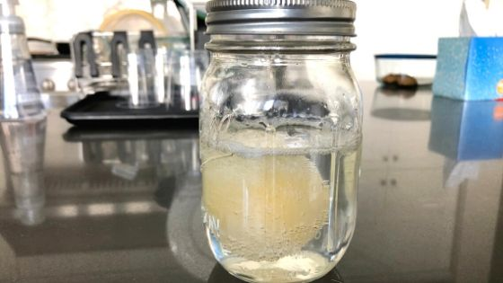

- Leave the egg in the vinegar for another 2 days.
- Gently take out the egg and rinse it with water.
- Bounce the egg by holding it 1-2 inches above a surface and letting go.

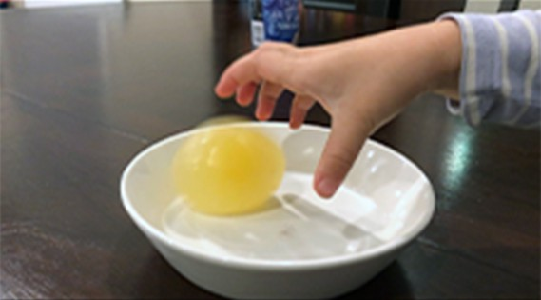
Tip: You will want to do this on a plate in case the egg breaks.

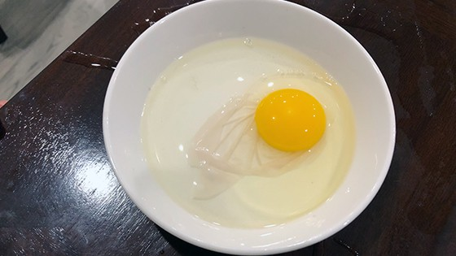
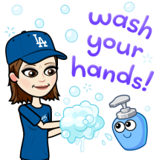
Make sure to wash your hands with soap and water after playing with the bouncy egg. Raw eggs contain salmonella bacteria that can make you and your kids really sick!

Bouncy Egg Variation:
Want to take this neat science experiment a step further? Add food coloring to the vinegar and make colorful bouncy eggs! We actually tried adding red food coloring to our egg, but the egg broke by accident when we moved the jar. Next time!

How Bouncy Eggs Work
The eggshell is made of calcium carbonate. When you submerge the egg in vinegar, the acid in the vinegar reacts with the calcium carbonate and produces carbon dioxide. This chemical reaction is what causes the little bubbles you see surrounding the egg.
As the shell dissolves, the thin membrane of the egg is left behind. The membrane is semi-permeable, which means the vinegar can pass through it. The egg absorbs the vinegar, and that’s why you see the egg increase in size as it continues to sit in the vinegar.

Final Thoughts on the Naked Egg Experiment
What came first, the chicken or the egg? While the world may never know the answer to this age-old question, we at least now know what the inside of an egg looks like thanks for this bouncy egg experiment.

Hope you and your kids enjoyed bouncing the egg!

Love, Mrs. Stack

